**SQL WORKSHEET-2**

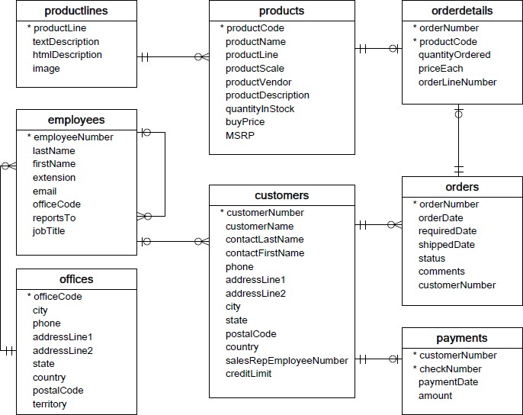

Refer the following ERD and answer all the questions in this worksheet. You have to write the queries using mysql for the required Operation.

* Customers: stores customer's data.

* Products: stores a list of scale model cars.

* ProductLines: stores a list of product line categories.

* Orders: stores sales orders placed by customers.

* OrderDetails: stores sales order line items for each sales order.

* Payments: stores payments made by customers based on their accounts.

* Employees: stores all employee information as well as the organization structure such as who reports to whom.

* Offices: stores sales office data.

**1. Write SQL query to create table Customers.**

**Ans:-**

Create table Customers(

CustomerNumber int not null,

CustomerName varchar(30) not null,

ContactLastName varchar(30) not null,

ContactFirstNAme varchar(30) not null,

Phone int not null,

AddressLine1 varchar(30) not null,

AddressLine2 varchar(30),

City varchar(30) not null,

State varchar(30) not null,

PostalCode int not null,

Country varchar(30) not null,

SalesRepEmployeeNumber int not null,

CreditLimt int not null,

primary key (CustomerNumber),

foreign key (SalesRepEmployeeNumber) references Employees(EmployeeNumber));

**2. Write SQL query to create table Orders.**

**Ans:-**

create table Orders(

OrderNumber Varchar(30) not null primary key,

OrderDate date not null,

RequiredDate date not null,

ShippedDate date not null,

Stat varchar(10) not null,

Comments varchar(30) not null,

CustomerNumber int not null,

foreign key ( CustomerNumber) references Customers(CustomerNumber));

**3. Write SQL query to show all the columns data from the Orders Table.**

**Ans:-** SELECT * FROM ORDERS;

|  |  |  |  |  |  |
| --- | --- | --- | --- | --- | --- |
| Field | Type | Null | Key | Default | Extra |
| orderNumber | int | NO | PRI | NULL |  |
| orderDate | date | YES |  | NULL |  |
| requiredDate | date | YES |  | NULL |  |
| shippedDate | date | YES |  | NULL |  |
| status | char(10) | YES |  | NULL |  |
| comments | varchar(50) | YES |  | NULL |  |
| customerNumber | int | YES |  | NULL |  |

**4. Write SQL query to show all the comments from the Orders Table.**

**Ans:-** SELECT Comments FROM orders;

**5. Write a SQL query to show orderDate and Total number of orders placed on that date, from Orders table.**

**Ans:-** SELECT orderdate as dates, count(orderNumber) as no_of_order from Orders group by dates;

**6. Write a SQL query to show employeNumber, lastName, firstName of all the employees from employees table.**

**Ans:-** SELECT EmployeeNumber, LastName, FirstName FROM Employees;

**7. Write a SQL query to show all orderNumber, customerName of the person who placed the respective order.**

**Ans:-** SELECT Ordernumber, Customernumber FROM ORDERS;

**8. Write a SQL query to show name of all the customers in one column and salerepemployee name in another column.**

**Ans:-** SELECT customerName,salesRepEmployeeNumber from Customers;

**9. Write a SQL query to show Date in one column and total payment amount of the payments made on that date from the payments table.**

**Ans:-** SELECT paymentDate as PaidOn, amount from payments group by PaidOn order by PaidOn asc;

**10. Write a SQL query to show all the products productName, MSRP, productDescription from the products table.**

**Ans:-** SELECT ProductName, MSRP, ProductDescription FROM Products;

**11. Write a SQL query to print the productName, productDescription of the most ordered product.**

**Ans:-** productName,productDescription,max(quantityOrdered) from products,orderdetails where products.productcode=orderdetails.productcode;

**12. Write a SQL query to print the city name where maximum number of orders were placed.**

**Ans:-** SELECT ProductName,max(QuantityOrdered) from Products,Orderdetails where Products.productcode = Orderdetails.productcode;

**13. Write a SQL query to get the name of the state having maximum number of customers.**

**Ans:-** SELECT state,count(customerNumber) from customers group by state order by count(customerNumber) desc limit 1;

**14. Write a SQL query to print the employee number in one column and Full name of the employee in the second column for all the employees.**

**Ans:-** SELECT EmployeeNumber, concat(FirstName," ",Lastname) as Full_name from Employees;

**15**. **Write a SQL query to print the orderNumber, customer Name and total amount paid by the customer for that order (quantityOrdered � priceEach).**

**Ans**:- SELECT Orders.OrderNumber, Customers.CustomerName, orderdetails.QuantityOrdered*orderdetails.PriceEach as amount_paid

from((Orders

inner join Customers on Orders.CustomerNumber=customers.CustomerNumber)

inner join orderdetails on Orders.OrderNumber=orderdetails.OrderNumber);